
ECOMONDO 2024: Daily Update, 5th November 2024

Integrated Solutions to Adapt Water Systems to Climate Change in Europe and the Mediterranean

An impressive 30% of the European population faces permanent water stress, and with a growing population and intensified climate change, ten European countries are projected to experience extreme water scarcity by 2040. An international workshop dedicated to integrated solutions for adapting water systems to climate change was hosted at Ecomondo in partnership with the Union for the Mediterranean and Water Europe, addressing urgent issues of water scarcity, flood risk, and the impacts of extreme weather on water systems in the Mediterranean.

The event featured contributions from prominent water management organisations and research institutions, including the Italian Institute for Environmental Protection and Research (ISPRA), Atmos International, Acquedotto Pugliese SpA, Marche Polytechnic University, and the University of Bologna, among others. Together, they explored innovative, holistic approaches to water management, such as ecosystem restoration, climate-smart agriculture, and resilient infrastructure.

Across three sessions, participants examined observed climate impacts, large-scale water industry solutions, and strategic EU-funded and international projects. Advanced approaches were presented, including early warning systems, such as those based on negative pressure wave techniques, as well as digital tools for sustainable water use. Nature-based solutions were also highlighted, focusing on the multifunctional use of green and blue spaces, which cover approximately 42% of urban areas in the EU, to promote health and well-being while enhancing urban resilience.

Coastal Resilience and Adaptation to Climate Change: A Challenge for Europe

A recent study by the European Institute for Economics and Environment (EIEE) warns that the sea level rise due to climate change could cost Europe up to €872 billion by 2100, with more than 40,000 km of Mediterranean coastline being at risk.

The session chair Roberto Montanari, official of the Emilia-Romagna Region responsible for coordinating European projects and international initiatives on coastal protection, highlighted: “In recent years, we have seen an intensification of extreme events across Europe, such as those in Emilia-Romagna and Valencia. Over the past 30 years, floods have impacted 5 million people, resulting in 3,000 fatalities and $170 billion in damages.” Montanari emphasised that, despite improvements in forecasting and planning for territorial resilience, “funding sources remain limited and fragmented”, and further expressed the need for “a Marshall Plan to tackle the climate change challenges”.

The discussion extended to the progress of Italy’s National Plan for Adaptation to Climate Change and the European best practices, such as the "Parco del Mare" project on Rimini’s waterfront, and the efforts of Irland and of the Hauts-de-France region to tackle coastal erosion. Nature-based solutions and data collection systems aimed at building coastal resilience, as well as specific challenges of low-lying, urbanised coasts were also highlighted.

Earth Observation and Digital Twins: Enhancing Urban Resilience

Professor Fabio Fava, President of the Ecomondo’s Scientific Technical Committee, noted “Digital technologies are a strategic and essential tool for addressing lots of sustainability aspects. Satellite data, real-time monitoring, and predictive analytics are crucial for more efficient, resilient, and sustainable cities, capable of effectively managing environmental emergencies,” noted.

In this context, Digital Twins - virtual replicas of physical entities - are emerging as one of AI’s most promising applications, enabling dynamic and interactive simulations of complex environments. They hold immense potential across urban infrastructure management, land-use planning, energy resource optimisation, and environmental monitoring.

The workshop led by the Foresight and Strategic Planning Office of the Politecnico di Torino showcased how Digital Twins can support ecosystems and infrastructure dynamic modelling, providing crucial insights for sustainable urban development, environmental protection, and resource management. Integrating high-resolution Earth observation data, these digital models enable near real-time monitoring and predictive analytics for urban planning.

Our Oceans from Space: Multimedia Exhibition Promoted by UNESCO

At Ecomondo, Planetek Italia unveiled Our Oceans from Space, a multimedia exhibition supporting the Ocean Decade – a global initiative led by UNESCO to bring scientists, policymakers, governments, industry leaders, and philanthropists together to address critical oceanic challenges. The exhibition highlights urgent issues such as ocean warming, the vulnerability of coastal areas (home to 40% of the global population), and the preservation of cultural heritage and biodiversity.

Earth observation technologies play a pivotal role in sustainable planning, including offshore renewable energy projects, directly supporting the European Green Deal. The exhibition takes visitors on an interactive journey through breathtaking satellite images of marine ecosystems and showcases stories on how satellite data is essential for monitoring and protecting our oceans and coastal zones. From trade to tourism, the oceans’ mobility, which enables the movement of people, goods, and services, has always been central to human progress and will remain crucial in the future.

For those interested in learning more about how space science and technology contribute to monitoring our oceans and atmosphere, Planetek Italia has developed a free online course in English that draws on Italy’s extensive expertise in the field, as the country ranks third globally in aerospace research.

NB! All events organized by Ecomondo’s Scientific Technical Committee support the European initiative “No Women No Panel”.

PRESS CONTACT - ITALIAN EXHIBITION GROUP
head of media & corporate communication: Elisabetta Vitali; press office manager: Marco Forcellini, Pier Francesco Bellini; international press office coordinator: Silvia Giorgi; press office coordinator: Luca Paganin; press office specialists: Nicoletta Evangelisti, Mirko Malgieri; media@iegexpo.it

MEDIA AGENCY

Hill & Knowlton
Francesca De Angelis, +39 342 7460159 - francesca.deangelis@hillandknowlton.com
Valentina Corsi - +39 3270425730 - valentina.corsi@hillandknowlton.com
Alessio Ricciuto - alessio.ricciuto@hillandknowlton.com

Stampa Estera - Oksana Smirnova - smirnova.consultant@hillandknowlton.com

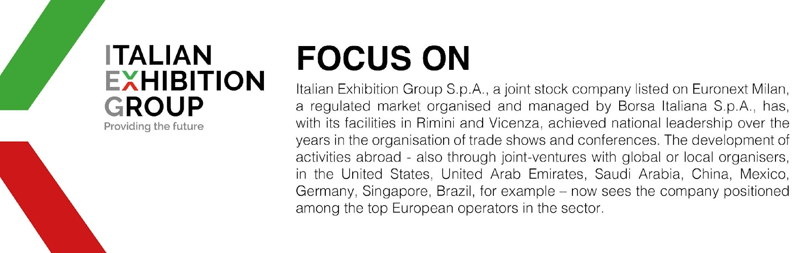

This press release contains forecast elements and estimates that reflect the management’s current opinions (“forward-looking statements”), particularly regarding future management performance, realization of investments, cash flow trends and the evolution of the financial structure. For their very nature, forward-looking statements have a component of risk and uncertainty, as they depend on the occurrence of future events. The effective results may differ (even significantly) from those announced, due to numerous factors, including, only by way of example: food service market and tourist flow trends in Italy, gold and jewellery market trends, green economy market trends; the evolution of raw material prices; general macroeconomic conditions; geopolitical factors and evolutions in the legislative framework. Moreover, the information contained in this release does not claim to be complete, and has not been verified by independent third parties. Forecasts, estimates and objectives contained herein are based on the information available to the Company as at the date of this release.

